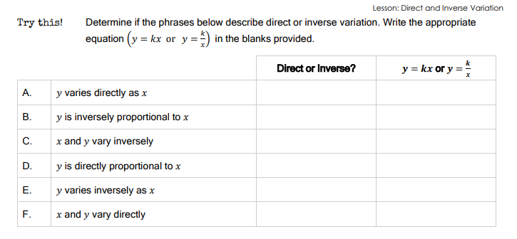
Examples

1. $y$ varies DIRECTLY with $x$.
If $y$ varies directly with $x$ and $y=10$ when $x=2$, find $y$ when $x=6$.

2. $y$ varies INVERSELY with $x$.
If $y$ varies inversely with $x$ and $y=3$ when $x=4$, find $y$ when $x=2$.

3. The sound produced by a string inside a piano depends on its length. The frequency of a vibrating string varies inversely as its length.

A. Write an equation that represents the relationship between frequency (f) and length (L). Use k for the constant of variation.

B. If you have two different lengths of string, which one vibrates faster (has the greatest frequency)?

C. Suppose a piano string 2 feet long vibrates 300 cycles per second. What would be the frequency of a string 4 feet long?

